Machine Learning Algorithms for Sentiment Analysis and Risk-Analysis in Monitor Report Forms:

**Introduction**

**Sentiment analysis** involves determining the sentiment or emotional tone expressed in a piece of text. This document evaluates three machine learning algorithms—Naive Bayes, Decision Tree Classifier, and Support Vector Machines (SVM)—in the context of sentiment analysis for monitor report forms.

**Consider a scenario where patient is diagnosing a medical condition. These features might be relevant:**

**Independent Features:**

Patient's Blood Type: Blood type might not be directly influenced by the medical condition.

Patient's Height: Height might be independent of the medical condition.

Patient's Birthdate: Birthdate is independent of the condition being diagnosed.

**Dependent Features:**

Symptoms Present: The presence or absence of symptoms can provide critical information about the medical condition.

Test Results: The results of specific medical tests can directly indicate the presence of the condition.

Family Medical History: The medical history of family members can indicate a genetic predisposition to certain conditions.

Linear Regression

* Linear regression is like drawing a straight line through a bunch of points on a graph. Imagine you have a set of data points that you think might be related, and you want to understand the relationship between them.
* For instance, think about how the height of a person might be related to their shoe size. You collect data on various people's heights and their corresponding shoe sizes. When you plot these points on a graph, they won't perfectly align in a straight line, but they might be close.
* Linear regression helps you find the best-fitting straight line that goes through these points. This line represents the general trend or pattern in the data. It helps you make predictions, like estimating someone's shoe size based on their height, or vice versa.
* So, in simple terms, linear regression is a way to find a straight line that summarizes the relationship between two things and allows you to predict one thing based on the other.

# Advantages

* **Simplicity**:

Linear regression is straightforward to understand and implement. The concept of fitting a line to data points is intuitive and can be easily explained to non-experts.

* **Interpretability:**

The coefficients of the linear regression equation have clear and interpretable meanings. They represent the change in the output variable for a one-unit change in the input variable.

* **Quick and Efficient:**

Linear regression models are computationally efficient, making them suitable for large datasets. They can be trained relatively quickly compared to more complex models.

* **Baseline Comparison:**

Linear regression provides a simple baseline model to compare against more complex algorithms. If the linear regression model performs well enough, there might not be a need for more intricate models.

* **Feature Importance:**

Linear regression can provide insights into which features have a significant impact on the output variable. Coefficients with larger absolute values indicate stronger feature importance.

# Disadvantages:

* **Assumption of Linearity:**

Linear regression assumes a linear relationship between the input variables and the output. If the true relationship is non-linear, the model may not perform well.

* **Limited Complexity:**

Linear regression is limited in capturing complex relationships within data. It might not be suitable for datasets with intricate interactions between variables.

* **Sensitive to Outliers:**

Linear regression can be sensitive to outliers, as the model aims to minimize the sum of squared errors. Outliers can disproportionately influence the line's placement.

* **Assumption of Independence:**

Linear regression assumes that the input variables are independent of each other. If there is multicollinearity (high correlation) between input variables, it can affect the model's reliability.

* **Under fitting:**

In cases where the true relationship is not well-approximated by a straight line, linear regression can under fit the data and produce inaccurate predictions.

* **Limited to Numeric Relationships:**

Linear regression is primarily suited for modeling numeric relationships. It might not work well when dealing with categorical or qualitative data.

In summary, linear regression is a simple and interpretable method that can be useful for understanding basic relationships between variables. However, its limitations in handling complex data patterns and non-linear relationships might require more advanced modeling techniques for better performance in those cases.

**Example:**

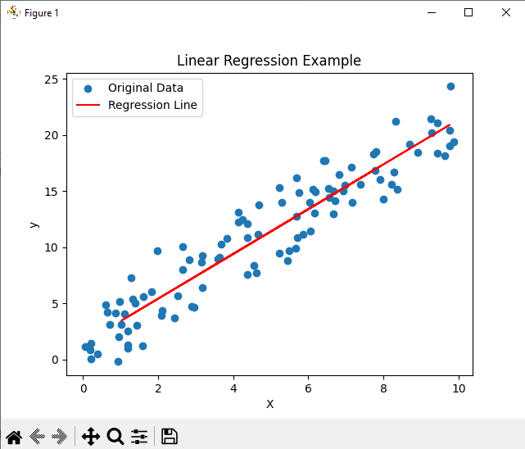

import numpy as np  
from sklearn.model_selection import train_test_split  
from sklearn.linear_model import LinearRegression  
import matplotlib.pyplot as plt  
  
*# Generate some example data*np.random.seed(0)  
X = np.random.rand(100, 1) * 10  
y = 2 * X + 1 + np.random.randn(100, 1) * 2  
  
*# Split the data into training and testing sets*X_train, X_test, y_train, y_test = train_test_split(X, y, test_size=0.2, random_state=42)  
  
*# Create a linear regression model*model = LinearRegression()  
  
*# Train the model on the training data*model.fit(X_train, y_train)  
  
*# Make predictions on the test data*y_pred = model.predict(X_test)  
  
*# Plot the original data and the regression line*plt.scatter(X, y, label="Original Data")  
plt.plot(X_test, y_pred, color='red', label="Regression Line")  
plt.xlabel("X")  
plt.ylabel("y")  
plt.title("Linear Regression Example")  
plt.legend()  
plt.show()

Logistic Regression

Logistic regression is a machine learning algorithm used for binary classification tasks, where the goal is to predict one of two possible outcomes. Despite its name, logistic regression is primarily used for classification, not regression.

* **Sigmoid Function:**

Logistic regression uses the sigmoid function (also called the logistic function) to transform any input into a value between 0 and 1. The sigmoid function has an S-shaped curve and can map any real-valued number to a probability between 0 and 1.

* **Linear Combination:**

Just like linear regression, logistic regression involves a linear combination of input features, each multiplied by a corresponding weight. However, instead of directly outputting this linear combination, it's passed through the sigmoid function.

* **Interpretation:**

The output of the sigmoid function can be interpreted as the predicted probability of belonging to one of the two classes. For example, in a binary classification problem like spam detection, the output could represent the probability of an email being spam.

* **Thresholding:**

To make an actual classification decision, a threshold is set (usually 0.5). If the predicted probability is above the threshold, the sample is classified into one class; otherwise, it's classified into the other class.

* **Training:**

The model's goal during training is to adjust the weights so that the predicted probabilities are as close as possible to the actual class labels in the training data. This is typically done by minimizing a loss function, like the cross-entropy loss.

# Advantages:

* **Interpretable Predictions:**

Logistic regression coefficients represent the influence of each feature on the log-odds of the outcome. This provides clear insights into how each feature affects the prediction.

* **Simple Implementation:**

Logistic regression is relatively easy to understand and implement, making it a good choice for a quick baseline model.

* **Efficient for Small Datasets:**

It can perform well with small datasets when the number of features is limited. It's computationally efficient and doesn't require extensive computational resources.

* **Probability Output:**

Logistic regression produces predicted probabilities for each class, which can be useful when you need to assess the uncertainty of predictions.

* **Feature Scaling Not Always Required:**

Logistic regression isn't as sensitive to feature scaling as some other algorithms, such as SVM or k-NN.

* **Low Risk of Over fitting:**

Logistic regression's simplicity makes it less prone to over fitting, especially when the dataset is smaller.

# Disadvantages:

* Limited Complexity: Logistic regression assumes a linear relationship between the features and the log-odds of the outcome. It might not capture complex relationships in the data.
* Binary Classification Only: Logistic regression is designed for binary classification problems. While there are extensions for multi-class problems (multinomial logistic regression), it might not be the best choice for highly multiclass scenarios.
* Assumption of Linearity: Just like linear regression, logistic regression assumes that the relationship between the features and the log-odds is linear. If the true relationship is non-linear, the model may not perform well.
* Susceptibility to Outliers: Outliers can disproportionately affect the coefficients and predictions, especially if they're near the decision boundary.
* Highly Imbalanced Data: If one class significantly outweighs the other in terms of the number of samples, logistic regression might struggle to predict the minority class well.
* Feature Engineering Importance: The performance of logistic regression heavily relies on feature selection and engineering. If the chosen features don't capture the underlying patterns, the model's performance might be poor.
* No Probability Calibration: The predicted probabilities from logistic regression might not be well-calibrated, meaning they might not represent true probabilities. Additional calibration might be needed for certain applications.

In summary, logistic regression is a simple and interpretable algorithm that's well-suited for binary classification problems, especially when the relationships are relatively linear and the dataset is not too large. However, its limitations in handling complex patterns and multiclass problems might require more advanced techniques in those cases.

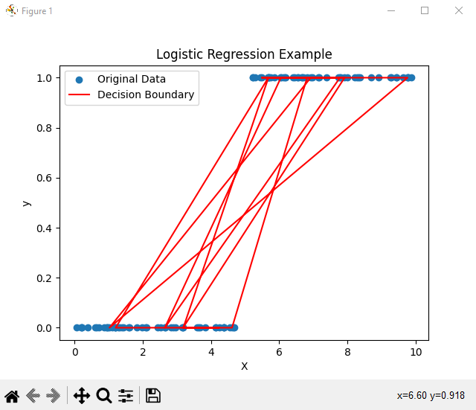

import numpy as np  
from sklearn.model_selection import train_test_split  
from sklearn.linear_model import LogisticRegression  
import matplotlib.pyplot as plt  
  
*# Generate some example data*np.random.seed(0)  
X = np.random.rand(100, 1) * 10  
y = (X > 5).astype(int)  
  
*# Split the data into training and testing sets*X_train, X_test, y_train, y_test = train_test_split(X, y, test_size=0.2, random_state=42)  
  
*# Create a logistic regression model*model = LogisticRegression()  
  
*# Train the model on the training data*model.fit(X_train, y_train)  
  
*# Make predictions on the test data*y_pred = model.predict(X_test)  
  
*# Plot the original data and the decision boundary*plt.scatter(X, y, label="Original Data")  
plt.plot(X_test, y_pred, color='red', label="Decision Boundary")  
plt.xlabel("X")  
plt.ylabel("y")  
plt.title("Logistic Regression Example")  
plt.legend()  
plt.show()

Naive Bayes

**Algorithm Overview:**

Naive Bayes is a probabilistic classification algorithm based on Bayes' theorem. It assumes that features are independent given the class label.

**Pros:**

**Efficiency**: Naive Bayes is computationally efficient, making it suitable for quick analysis with limited resources.

**Simplicity**: It's easy to understand and implement, making it an ideal choice for rapid prototyping.

**Scalability**: Performs well with high-dimensional data, such as text comments.

**Handles Missing Data**: Can handle missing values by ignoring them during probability calculations.

**Cons**:

**Limited Expressiveness**: Struggles to capture complex relationships between words and sentiments.

**Sensitive to Feature Quality**: Performance relies heavily on the quality of features, which can impact accuracy.

Decision Tree Classifier

**Algorithm Overview:**

**Decision trees recursively partition the data based on features, creating a tree structure that leads to classification decisions.**

**Pros**:

**Interpretability**: Decision trees are visually interpretable, aiding in understanding the decision-making process.

**Non-linearity Handling**: Effective at capturing non-linear relationships in data without complex preprocessing.

**Feature Importance**: Provides insight into feature importance, facilitating feature selection.

**Handles Missing Data**: Can manage missing values by assigning probabilities to outcomes based on available data.

**Cons**:

**Over fitting**: Decision trees can over fit, creating overly complex models that generalize poorly.

**Instability**: Small changes in data can lead to different tree structures, making them sensitive to variations.

**Bias towards Dominant Classes**: Unbalanced datasets might result in biased trees that favor dominant classes.

Support Vector Machines (SVM)

**Algorithm Overview:**

SVMs find the hyperplane that best separates classes, aiming to maximize the margin between data points.

**Pros**:

**High-Dimensional Spaces**: Effective in high-dimensional spaces, making them suitable for text comments.

**Kernel Trick**: Can capture non-linear relationships between words and sentiments through kernel functions.

**Margin Maximization**: SVMs generalize well by maximizing the margin between classes.

**Regularization**: Includes regularization parameters to control model complexity.

**Cons**:

**Computational Intensity**: Can be computationally expensive, particularly with large text datasets.

**Hyperparameter Sensitivity**: Performance is affected by kernel choice and other hyperparameters.

**Data Preprocessing**: Requires careful text preprocessing (tokenization, stopwords removal) for optimal results.

**Recommendation for Sentiment Analysis and risk analysis in Monitor Report Forms**

Support Vector Machines (SVM) is recommended due to its ability to handle high-dimensional text data and capture complex relationships between words and sentiments. Proper preprocessing of text data, combined with SVM's capacity to maximize margins and handle non-linear relationships, can lead to accurate sentiment predictions**.**

However, it's important to perform experimentation and hyper parameter tuning to achieve the best performance with the specific dataset we have. As text data can vary widely, consider leveraging techniques such as Bag of words, TF-IDF or Word2Vec to represent the comments effectively.

# Bag of Words (BoW):

Representation: BoW represents a document as a collection of word counts, disregarding word order and context.

**Pros:** Simple to implement, captures presence/absence of words, suitable for simple tasks.

**Cons:** Ignores word order and context, treats all words equally, may not capture word importance.

# TF-IDF (Term Frequency-Inverse Document Frequency):

Representation: TF-IDF takes into account word frequency in a document and its rarity across the entire corpus.

**Pros:** Considers word importance, highlights unique words, useful for text classification and retrieval.

**Cons:** Still doesn't capture word semantics or relationships, context.

# Word2Vec:

Representation: Word2Vec learns dense vector representations of words, capturing semantic relationships based on co-occurrence patterns.

**Pros:** Captures semantic relationships, produces informative embedding’s, useful for various NLP tasks.

**Cons:** Requires substantial training data, may not perform well with limited context, complex architecture.

**Recommendation for Sentiment Analysis on Monitor Report Forms:**

For sentiment analysis on monitor report forms where we have a single feature (comments) and a target label (sentiment), Word2Vec is recommended. This is because sentiment analysis benefits from capturing the semantic relationships between words, which Word2Vec does effectively.

**Pros of Word2Vec for Sentiment Analysis:**

Captures nuanced relationships between words, including synonyms and context.

Provides dense and informative embeddings, enhancing model understanding.

Effective in capturing sentiment nuances even with limited context.

**Cons of Word2Vec for Sentiment Analysis:**

Requires a substantial amount of training data for meaningful embeddings.

Can be computationally intensive during training.

May not be as straightforward to implement as BoW or TF-IDF.

**While BoW and TF-IDF are simpler techniques, Word2Vec's ability to capture word semantics and relationships makes it a better choice for sentiment analysis, especially when dealing with natural language text that requires understanding context and subtle differences in sentiment expressions. But we need adequate amount of relevant training data to train meaningful Word2Vec embedding’s.**